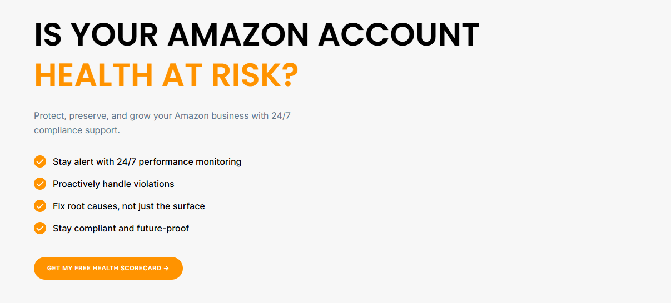

Section 1 — Hero
H1: Is Your Amazon Account Health in Danger?
Subtext: Protect, maintain, and grow your Amazon business with 24/7 Amazon account health monitoring and compliance support.
Bullets:
- Stay on top of issues with 24/7 performance tracking.
- Handle violations before they grow.
- Get lasting fixes instead of quick patches
- Stay compliant and ready for what’s next.
CTA Button: Get My Free Health Scorecard



Section 2 — Partners Strip
Label:
Partners With
(Logos stay as they are)

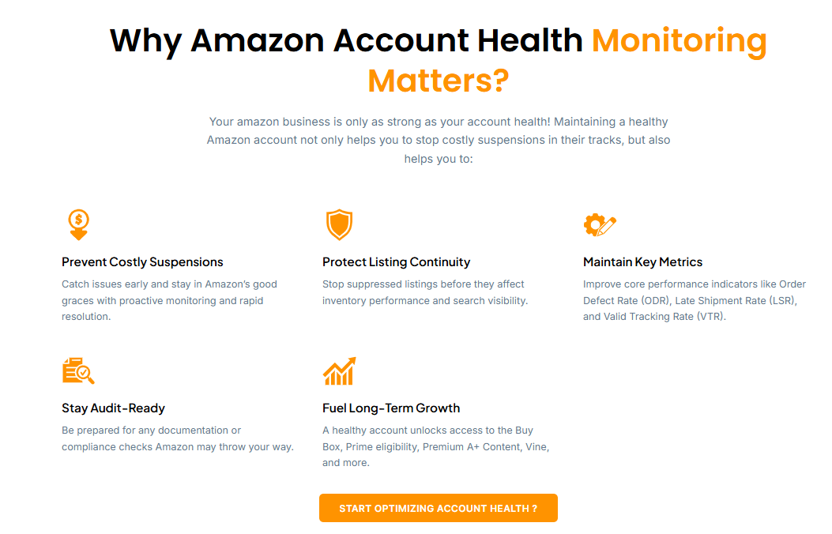

Section 3 — Why Monitoring Matters
H2: Why Amazon Account Health Monitoring Is Essential
Subtext: Your Amazon business is only as strong as your account health. A healthy account helps prevent Amazon suspension before it happens, and it also helps you:

Card 1 — Avoid Costly Suspensions
Spot problems early and stay on Amazon’s good side with proactive tracking and quick fixes.

Card 2 — Keep Listings Live
Stop listing suppressions before they hurt your inventory performance and search visibility.

Card 3 — Protect Key Metrics
Improve your Amazon seller performance metrics, like Order Defect Rate (ODR), Late Shipment Rate (LSR), and Valid Tracking Rate (VTR).

Card 4 — Stay Audit-Ready
Be ready for any documentation or compliance check Amazon sends your way.

Card 5 — Support Long-Term Growth
A healthy account opens the door to the Buy Box, Prime eligibility, Premium A+ Content, Vine, and more.
CTA Button: Start Improving Account Health

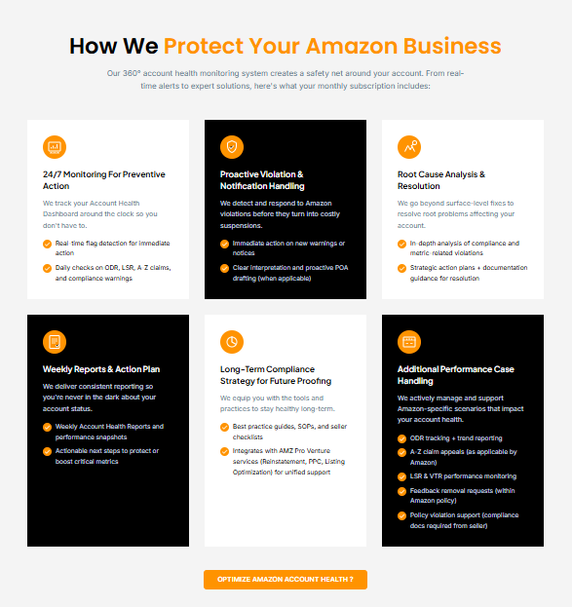

Section 4 — How We Protect Your Business
H2: How We Keep Your Amazon Business Safe
Subtext: Our 360° monitoring system builds a safety net around your account. From real-time alerts to expert fixes, here’s what your monthly plan includes:

Card 1 — 24/7 Monitoring to Prevent Problems
We watch your Account Health Dashboard around the clock, so you don’t have to.
- Real-time flag detection for quick action
- Daily checks on ODR, LSR, A-to-Z claims, and compliance warnings

Card 2 — Fast Violation and Notice Handling
We spot and respond to Amazon violations before they turn into costly suspensions.
- Quick action on new warnings or notices
- Clear explanations and proactive POA writing (when needed)

Card 3 — Root Cause Analysis and Fixes
We go deeper than quick fixes to solve the real problems affecting your account.
- Detailed analysis of compliance and metric-related violations
- Action plans plus guidance on the documents you’ll need

Card 4 — Weekly Reports and Action Plans
Regular reporting keeps you informed about your account at all times.
- Weekly Account Health reports and performance snapshots.
- Clear next steps to protect or improve key metrics

Card 5 — Long-Term Compliance Strategy
We give you the tools and habits to keep your account healthy long term.
- Best practice guides, SOPs, and seller checklists
- Works alongside other AMZ ProVenture services (Reinstatement, PPC, Listing Optimization) for complete support

Card 6 — Extra Performance Case Support
We actively manage Amazon-specific issues that affect your account health.
- ODR tracking and trend reports
- A-to-Z claim appeals (where Amazon allows)
- LSR and VTR performance tracking
- Feedback removal requests (within Amazon policy)
- Policy violation support (compliance documents provided by the seller)
CTA Button:
Optimize My Account Health

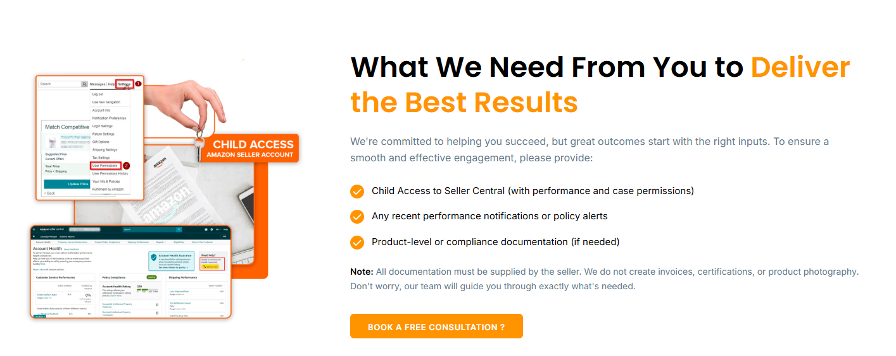

Section 5 — What We Need From You
H2: What We Need From You to Get the Best Results
Subtext: In order to begin, we first require some information about your business. This will help us to determine your requirements and provide the appropriate assistance.
Bullets:
- Child access to Seller Central (with performance and case permissions)
- Any recent performance notices or policy alerts
- Product or compliance documents (if needed)
Note:
All documents must come from you. We don’t create invoices, certifications, or product photos, but our team will guide you on exactly what you need.
CTA Button: Book a Free Consultation

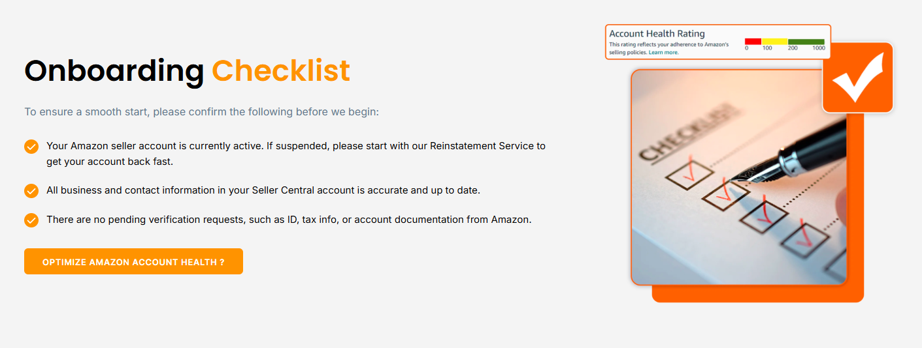

Section 6 — Onboarding Checklist
H2: Your Onboarding Checklist
Subtext: For a smooth start, please confirm the following before we begin:
Bullets:
- Your Amazon seller account is active. If it’s suspended, start with our Reinstatement Service to get it back quickly.
- All business and contact details in Seller Central are correct and up to date.
- Amazon has no pending verification requests, such as ID, tax info, or account documents.
CTA Button: Optimize My Account Health

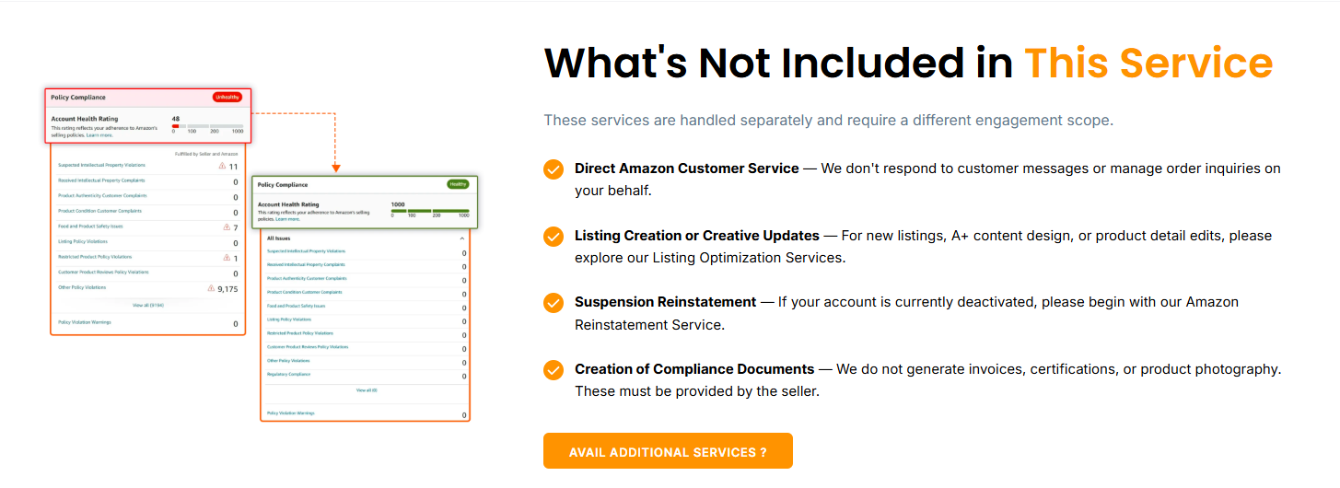

Section 7 — What’s Not Included
H2: What This Service Doesn’t Cover
Subtext: These services are handled separately and need their own scope of work.
Bullets:
- Direct Amazon Customer Service: We don’t reply to customer messages or manage order questions for you.
- Listing Creation or Creative Updates: For new listings, A+ Content design, or product detail changes, check out our Listing Optimization Services.
- Suspension Reinstatement: If your account is currently deactivated, please start with our Amazon Reinstatement Service.
- Compliance Document Creation: We don’t create invoices, certifications, or product photos. These must come from the seller.
CTA Button: Explore Other Services

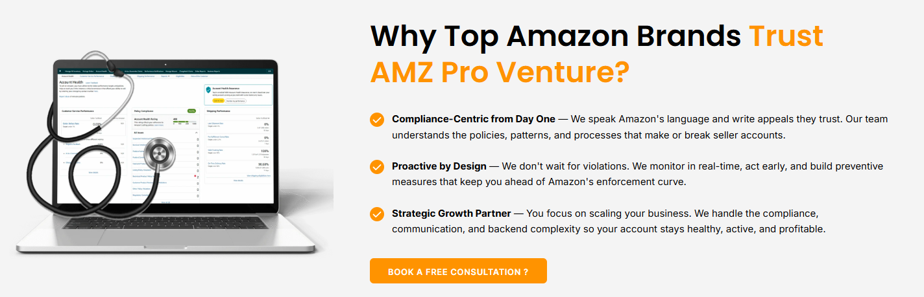

Section 8 — Why AMZ ProVenture
H2: Why Leading Amazon Brands Choose AMZ ProVenture
Bullets:
- Compliance-First From Day One: We understand Amazon’s rules and write appeals they trust. Our team knows the policies, patterns, and processes that can make or break a seller account.
- Proactive by Design: We don’t wait for violations. We track your Amazon account health rating in real time, act early, and put safeguards in place that keep you ahead of Amazon’s enforcement.
- A Partner in Your Growth: You focus on growing your business. We handle the compliance, communication, and behind-the-scenes work so your account stays healthy, active, and profitable.
CTA Button: Book a Free Consultation

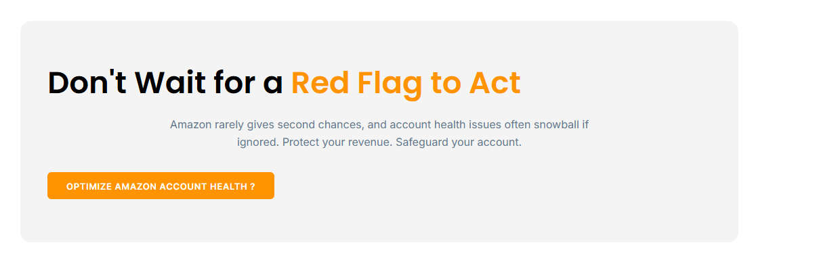

Section 9 — CTA Band
H2: Act Before a Red Flag Appears
Subtext: Amazon rarely offers second chances, and small health issues can quickly grow if ignored. Protect your sales and keep your account safe.
CTA Button: Optimize My Account Health

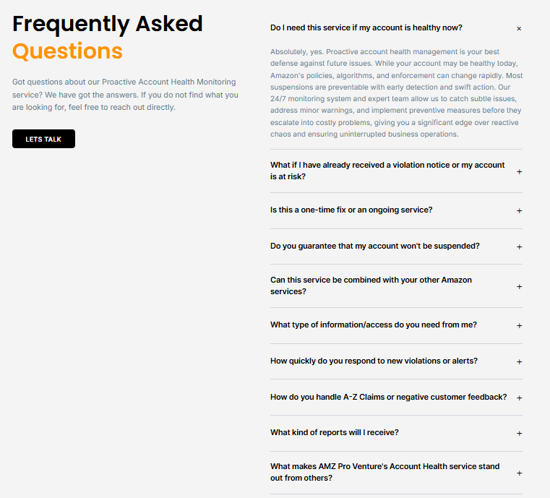

Section 10 — FAQ
H2: Frequently Asked Questions
Subtext: Have questions about our Amazon account health monitoring service? You’ll find the answers here. If not, feel free to reach out directly.
CTA Button: Let’s Talk

Q: Do I need this service if my account is healthy right now?
Yes. Even a healthy account can change quite rapidly as Amazon continually updates its policies and enforcement. Most suspensions can be prevented with early detection and our 24/7 monitoring is designed to pick up the early warning signs before they escalate into major issues. That way your account remains in good standing and your business can keep running.

Q: What if I’ve already received a violation notice or my account is at risk?
That's the right time to get started. We'll look at the notice, establish the cause and respond promptly (with a Plan of Action if required) to safeguard your account.

Q: Is this a one-time fix or an ongoing service?
It’s an ongoing monthly service. Your account health changes daily, so continuous monitoring is what keeps it protected.

Q: Can you guarantee my account won’t be suspended?
No one can guarantee that, since Amazon makes the final decisions. We greatly reduce your risk by spotting issues early and acting fast to prevent Amazon suspension.

Q: Can this service be combined with your other Amazon services?
Yes. It works alongside our Reinstatement, PPC, and Listing Optimization services, giving you one team for complete account support.

Q: What information or access do you need from me?
Child access to Seller Central with performance and case permissions, any recent notices or alerts, and compliance documents if they’re needed.

Q: How quickly do you respond to new violations or alerts?
We're monitoring 24/7 and acting as soon as a new flag comes in so we deal with issues before they've had a chance to get out of hand.

Q: How do you handle A-to-Z claims or negative feedback?
We appeal eligible A-to-Z claims, request removal of the feedback where permitted under Amazon policy and monitor the trends that impact your Amazon seller performance metrics.

Q: What kind of reports will I get?
You'll get weekly Account Health reports which will include performance snapshots, any changes to your Amazon Account Health Rating and clear next steps.

Q: What makes AMZ ProVenture’s Account Health service different?
We combine 24/7 monitoring, root cause fixes, and long-term compliance planning in one service, so you’re protected today and prepared for what’s ahead.

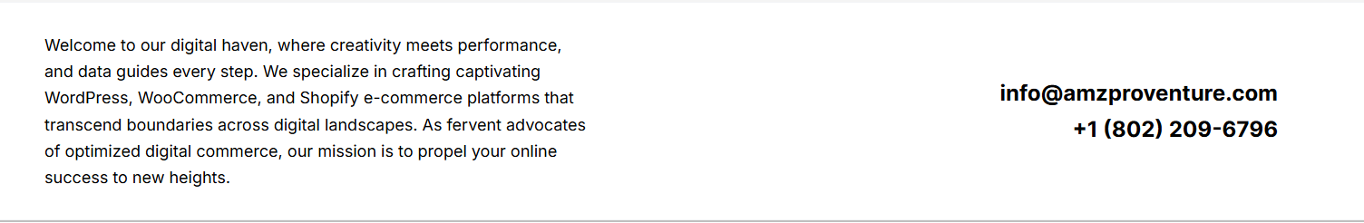

Section 11 — Footer Intro
Paragraph:
AMZ ProVenture helps Amazon sellers across the USA keep their accounts safe and growing. Our Amazon account health monitoring tracks your Amazon account health rating and Amazon seller performance metrics around the clock to help prevent Amazon suspensions before they start.

